Environmental Monitoring:

Analyzing Temperature Gradient

Welcome to our presentation on Environmental Monitoring and the importance of analyzing

temperature gradient in different places. Join us as we explore the world of temperature data and its

impact on our environment.



Introduction to Environmental

Monitoring

Environmental monitoring is the process of assessing and managing environmental quality to ensure

the well-being of ecosystems and human health. It involves collecting data on various environmental

parameters, including temperature, to understand the changes and trends over time.

Importance of Temperature Gradient

Analysis

Temperature gradient analysis helps us understand how temperature varies across different locations.

By analyzing temperature changes, we can gain insights into climate patterns, identify potential

environmental risks, and make informed decisions for conservation and sustainable development.

Different Feature Engineering

Techniques for Temperature Data

Temporal Aggregation

Combine temperature measurements over a

specific time period to uncover long-term

trends and seasonal patterns.

Spatial Interpolation

Estimate temperature values for unobserved

locations based on nearby measurements,

allowing us to map temperature distribution

more accurately.

Feature Scaling

Normalize temperature data to ensure that

different scales or units do not affect the

analysis and modeling process.

Outlier Detection

Identify and handle extreme temperature

values that deviate significantly from the

overall pattern, improving the quality of the

analysis and models.

Model Training Process

1

Data Preparation

Collect and preprocess temperature data, ensuring data quality, handling missing

values, and transforming the dataset into a suitable format for modeling.

2

Feature Selection

Select the most relevant temperature features that contribute to the predictive power

of the model while reducing complexity and computational requirements.

3

Model Selection & Training

Choose the appropriate machine learning or statistical model, train it using the

prepared dataset, and fine-tune the model to achieve optimal performance.

4

Model Evaluation

Assess the performance of the trained model using evaluation metrics to measure

accuracy, precision, recall, and other relevant indicators.



Evaluation Metrics for Model

Performance Analysis

Mean Absolute Error (MAE): Measures the average absolute difference

between predicted and actual temperature values.

Root Mean Squared Error (RMSE): Calculates the square root of the

mean of squared differences between predicted and actual values.

Provides a measure of overall model accuracy.

Coefficient of Determination (R²): Determines the proportion of the

variance in the temperature data that can be explained by the model.

Indicates how well the model fits the data.



Results from Temperature Gradient

Analysis

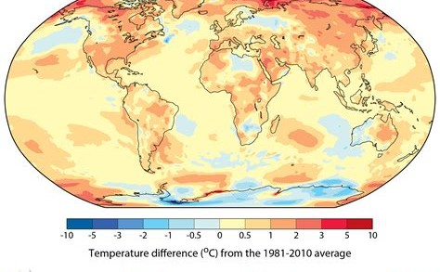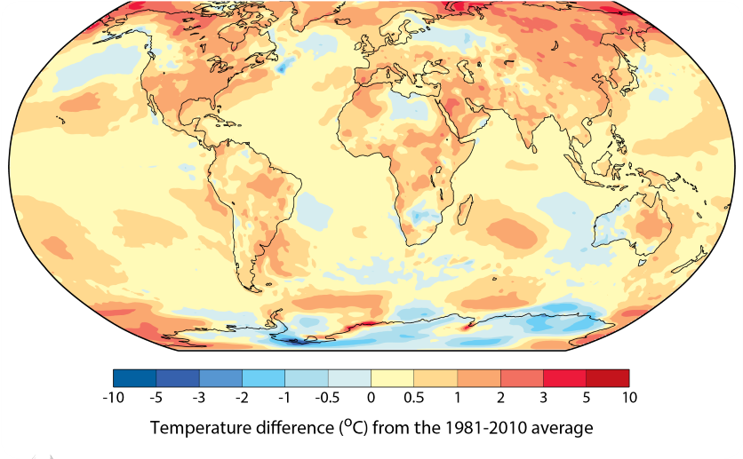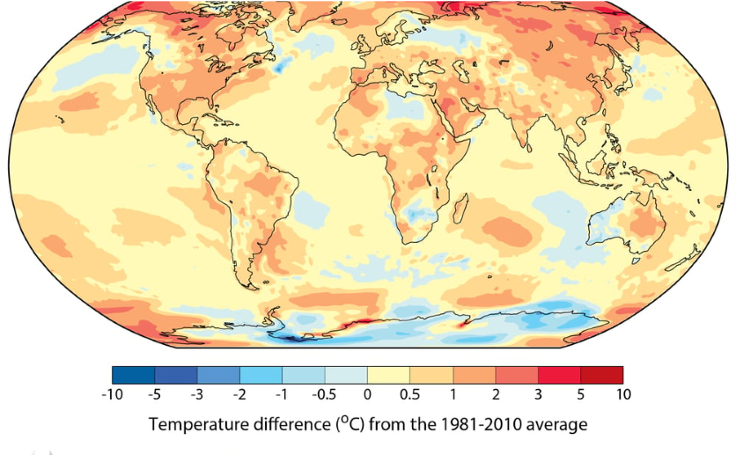

Global Temperature

Distribution

Visualize the temperature

gradient worldwide, revealing

areas of significant variation

and potential climate hotspots.

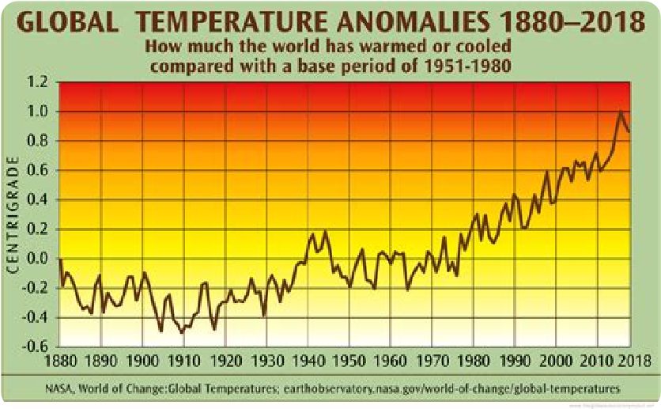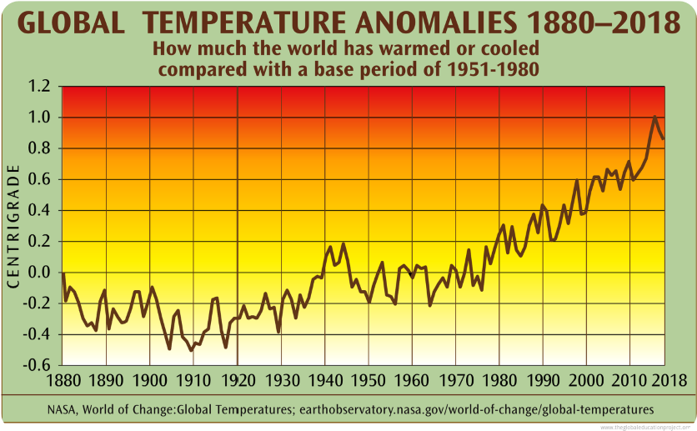

Temperature Anomalies

Identify regions experiencing

abnormal temperature patterns

or undergoing dramatic

temperature shifts, aiding in

climate change research.

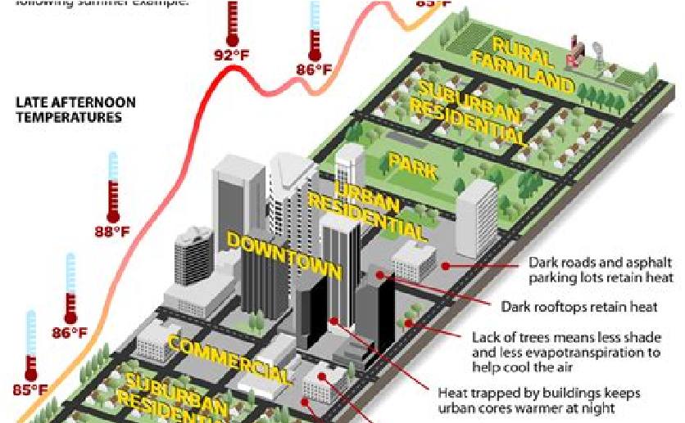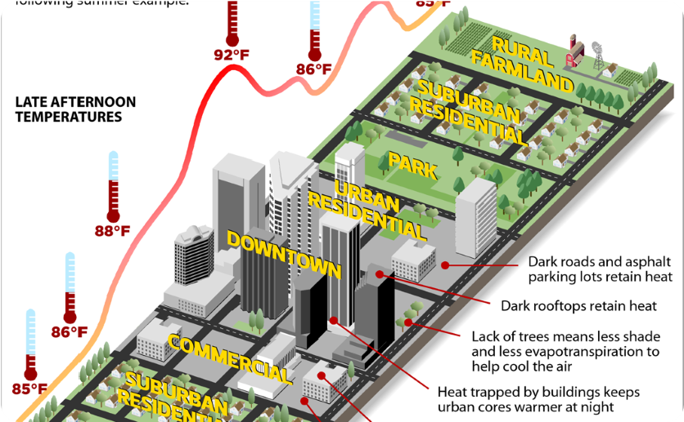

Urban Heat Island Effect

Explore the phenomenon of

urban areas having higher

temperatures compared to

rural regions, leading to

environmental and health

implications.

Conclusion and Future

Directions

By analyzing temperature gradients and employing advanced feature

engineering techniques and models, we can gain valuable insights into

climate dynamics, environmental risks, and sustainable development

strategies. Our findings can guide policymakers in implementing

effective measures to mitigate climate change and ensure a healthier

planet for future generations.



Details

PROJECT TITLE: ENVIRONMENTAL MONITORING :

ANALYZING TMEPERATURE GRADIENT

Name: KARTHICK P

REG NUMBER:410721104060

PHASE: DEVELOPMENT PART-2